CERTIFICATE OF HEALTH

Attach your latest photograph here
(3x4)

Note:
- This form must be completed by an examining physician in government hospital or medical laboratory (laboratorium klinik).
- All items in the form must be completed. Incomplete form will not be accepted.

Full Name: ______________________________________________________________

Place and Date of Birth:
___________________________
☐ Male ☐ Female

Contact Number:
___________________________

- Are you under medical treatment?If yes, please describe your medical conditions and treatment.
☐ Yes ☐ No
 | Yes | dd/mm/yy |  | Yes | dd/mm/yy
Tuberculosis |  |  | Malaria
Other communicable disease |  |  | Epilepsy
Kidney disease |  |  | Heart disease
Diabetes |  |  | Drug allergy
Psychosis |  |  | Functional disorder in exremities
____________________________________________________________________________________________________________________________________________________________________________________________________________________________________________________________________________________

- Medical history: If yes, please check and fill in the date of recovery.

- Physical examination

  - Height: _______ cm
Weight: _______ kg

  - Blood pressure: ______ ~ ______ mmHg Pulse: ☐ regular ☐ irregular

  - Eyesight:
Without glasses | (R) | (L)
With glasses | (R) | (L)

  - Hearing: ☐ Normal
☐ Impaired
Speech: ☐ Normal
☐ Impaired

  - Anemia: ☐ Yes
☐ No
  - Breath sound: ☐ Normal
☐ Impaired
  - Heart sound: ☐ Normal
☐ Impaired

Cardiomegaly: ☐ Yes
☐ No

Electrocardiograph: ☐ Normal
☐ Impaired

- Please describe the result of X-ray examination of the applicant’s chest.
The examination date and Film No.are exclusively needed.
(X-rays taken more than 2 months prior to this examination are NOT valid.
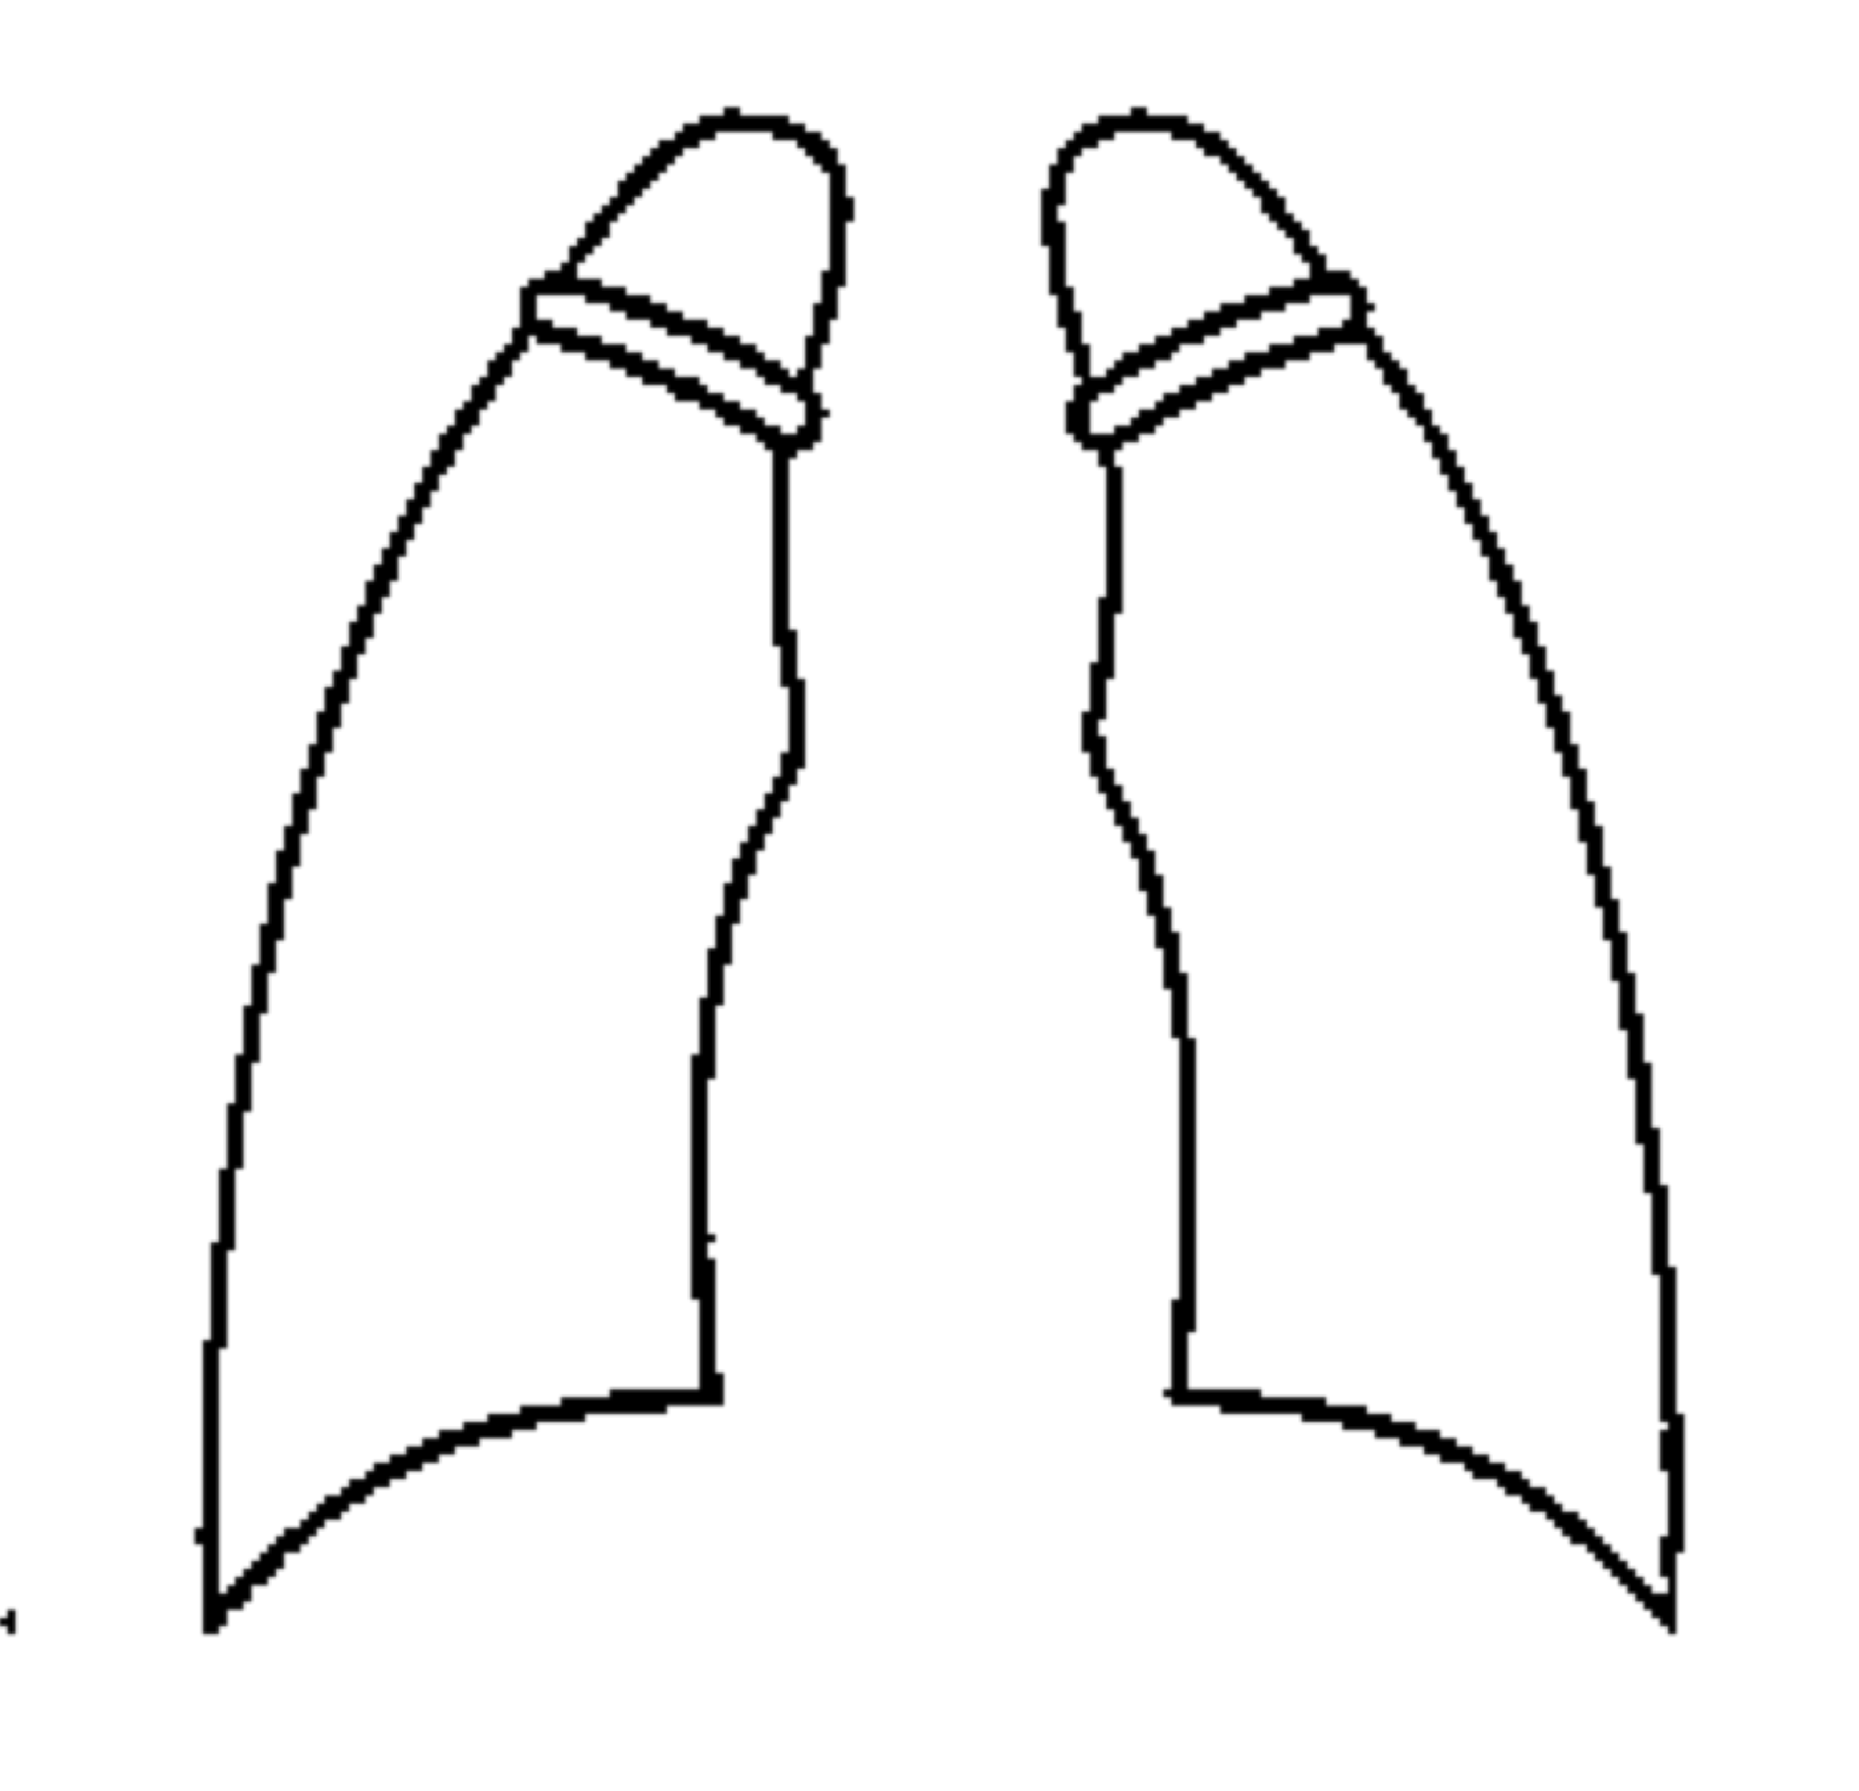
Lungs: ☐ Normal
☐ Impaired
Date: / / (dd/mm/yy)
Film No.: -
Describe the condition of the applicant’s lungs.
______________________________________________________
______________________________________________________

- Laboratory tests
Blood type: ☐ A ☐ B ☐ O ☐ AB RH: ☐ + ☐ -
Urinalysis: glucose ( ____ ), protein ( ____ ), occult blood ( ____ )
ESR: ________ mm/Hr WBC count: _________ / mm³
Hemoglobin: _______ gm/dl GPT (ALT): _________ / U/L

- In view of the applicant’s medical history and the above findings, do you think that his/her health status is adequate to meet the demands of studying abroad?
☐ Yes ☐ No

- Particulars or additional comments:
____________________________________________________________________________________________________________________________________________________________________________________________________________________________________________________________________________________

and seal
Medical institution: ________________________________________________

Address: _________________________________________________________

Telephone number: ____________________________

Physician’s name: _____________________________

Physician’s signature: __________________________ Date: / / -
(dd/mm/yy)

Medical institution: ________________________________________________

Address: _________________________________________________________

Telephone number: ____________________________

Physician’s name: _____________________________

Physician’s signature: __________________________ Date: / / -
(dd/mm/yy)

